

**NOIDA INSTITUTE OF ENGINEERING AND TECHNOLOGY MINI PROJECT (KCS - 354)**

**Department of Computer Science and Engineering**

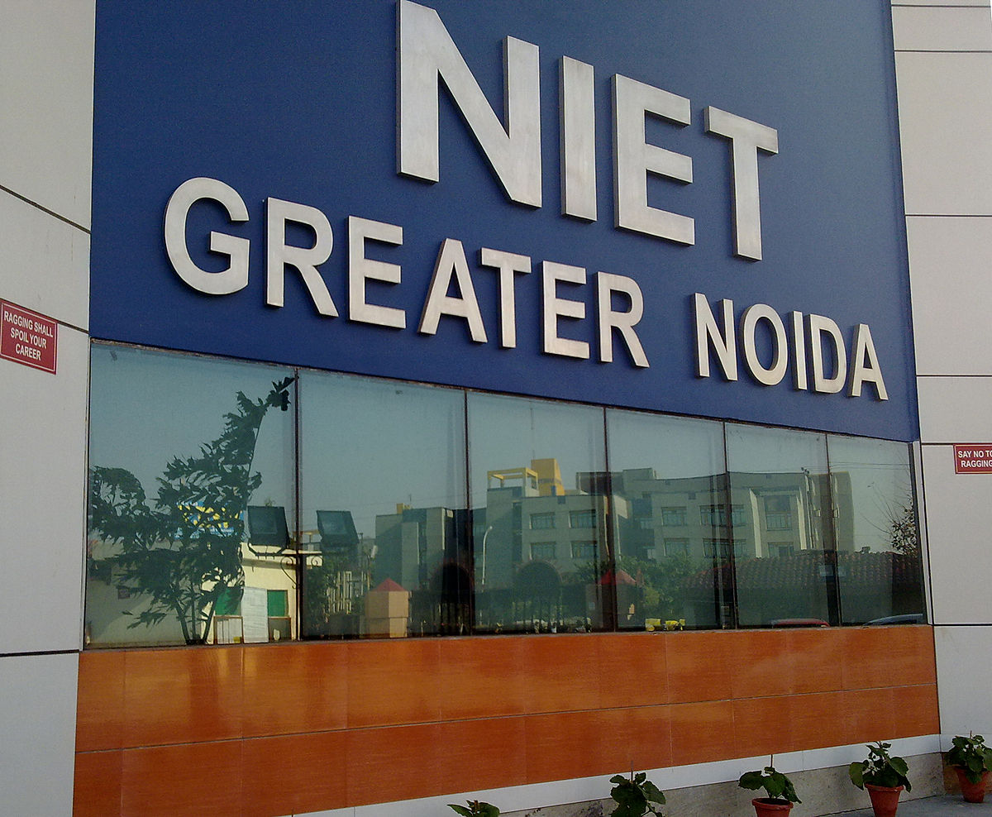

**SUBMITTED BY: SUBMITTED TO:**

**Rishika Garg Ms Sheelu Rani**

**Raj Aditya Mishra**

***Certificate***

***Acknowledgement***

I would like to place on record my deep sense of gratitude to Ms. Sheelu Rani (assistant professor), in Department of Computer Science and Engineering, Noida Institute of Engineering & Technology, Greater Noida, Gautam Budha Nagar, Uttar Pradesh, India for her generous guidance, help and useful suggestions. I express my sincere gratitude to Prof. Chandra Shekhar Yadav, HOD(CSE), Noida Institute of Engineering & Technology, Greater Noida for his stimulating guidance, continuous encouragement and supervision throughout the course of present work.

STUDENT’S NAME

RISHIKA GARG

(1901330100224)

***Index***

|  |  |  |
| --- | --- | --- |
| ***S.NO*** | ***TOPIC*** | ***SIGNATURE/REMARKS*** |
| ***1*** |  |  |
| ***2*** |  |  |
| ***3*** |  |  |
| ***4*** |  |  |
| ***5*** |  |  |
| ***6*** |  |  |
| ***7*** |  |  |
| ***8*** |  |  |
| ***9*** |  |  |
| ***10*** |  |  |
| ***11*** |  |  |
| ***12*** |  |  |
| ***13*** |  |  |

**Synopsis on**

**Education donation site**

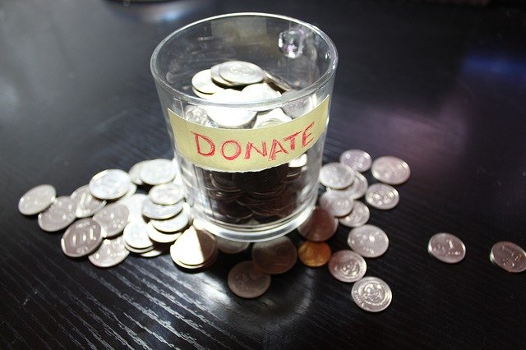

***DONATE TO EDUCATE***

Introduction to Project:

Donate to Educate

With schools shut due to the fear of Covid-19 virus, the morning bell is now the caller tune of a zoom call. The Classroom is the Laptop, Desktop, tablet! or mobile phone. Somewhere along the line the TV too, butts in.

The pandemic has had a deleterious effect on many aspects of ‘normal’ life. Business, Social events, Employment, Income, and even governance, and the grass is not that green on the other side! Children too find it difficult to stay in the education zone without an electronic device, and their parents are in a worse situation because of the guilt.

But amid the gloom there is hope. We created a site that would accept donation of used/unused electronics (smartphones, laptops, etc.) to support and enable the students, especially that of government schools to facilitate their continuing education via the virtual route.

***DONATE TO EDUCATE***

Objective:

Motivation

There have been a number of student suicide cases during the lockdown period where the students allegedly found it difficult to attend the online classes due to the lack of devices. The Madras High Court, on Monday (24th August), expressed concerns over the cases of suicide among school students in the state due to the inability to obtain the necessary devices and directed the state govt. to regulate online education. While surveying 2000 parents of school-aged children (aged 5-18) revealed that 40% children don’t have access to WhatsApp. Nearly 16 lakh children from poor families studying in govt. and municipal schools in the national capital are staring at disruptions in their studies without access to mobiles, internet and laptops or desktops, even as privileged students from private schools are taking online classes amid the Covid-19 lockdown.

Still in these worse times there are NGOs who’ve decided to help the students from marginalised communities by giving them smartphones, laptops through donation.

***DONATE TO EDUCATE***

Literature Review:

Education for all… But how does it work?

Driven by technology, and learning systems being the priority, the company (Cashify) has unveiled an initiative for its consumers to support the ones who are in need. The company is currently partnered by Delhi- NCR based NGOs such as Mera Parivar, Avanti Fellows, SSMI, Saarthi, Saajha, Charter for Compassion, Freepathshala, Kilkari, CBN, Khushii, Noor Girl Up.

Here's how it works: Consumers donate unused workable smartphones. The Company refurbishes them and provides them to the kids associated with the partnered smartphone, NGOs. If any consumer has a used/unused they can directly select the brand and model on the website, indicating their contact/identity details or address. Later, an executive will pick up the mobile phone after the order gets confirmed. Then it is refurbished handing it out to the children who are in need. Tasks such as delivery, communicating to the households etc, are carried out by the Cashify team, including customer support, pick up execs, and the warehouse QC team. The team is able to pick up in all locations in India that are not under any city-wide lockdown. The headquarters of the company is located in Gurugram. company is located in Gurugram.

***DONATE TO EDUCATE***

**MODULES:**

**HOME:**

The home page will have all the details regarding our site. It will have some interactive user interface.

**CONTRIBUTERS:**

This section will contain a gallery of all the contributions made.

**VOLUNTEERS:**

This section will display the volunteers in our community and will have a form that will let the visitors join the community

**DONATE:**

This section will have a form that will take user info and let them join and make donations.

**ABOUT US:**

This section will tell the users about the working of our community and they can also send their questions and doubts.

**NAVIGATION BAR:**

Present in all the pages it’ll help the users to navigate the above modules

**FOOTER:**

Footer will contain the links to various social media the contact info and the address

***DONATE TO EDUCATE***

Requirements:

**Software Requirement Specifications**

|  |  |
| --- | --- |
| **LANGUAGE USED** | JAVASCRIPT, PHP |
| **DATABASE** | MY SQL |
| **USER INTERFACE DESIGN** | HTML, CSS, JS |
| **WEB BROWSER** | CHROME, MOZILLA, EXPLORER |
| **SOFTWARE** | VISUAL STUDIO CODE |

**Hardware Requirement Specifications**

|  |  |
| --- | --- |
| **MONITOR** | COLOR MONITOR |
| **HARD DISK** | 40GB |
| **RAM** | 1GB |
| **PROCESSOR** | PENTIUM IV |
| **OPERATING SYSTEM** | WINDOWS 7,8,10 |

***DONATE TO EDUCATE***

Software Development Lifecycle (SDLC):

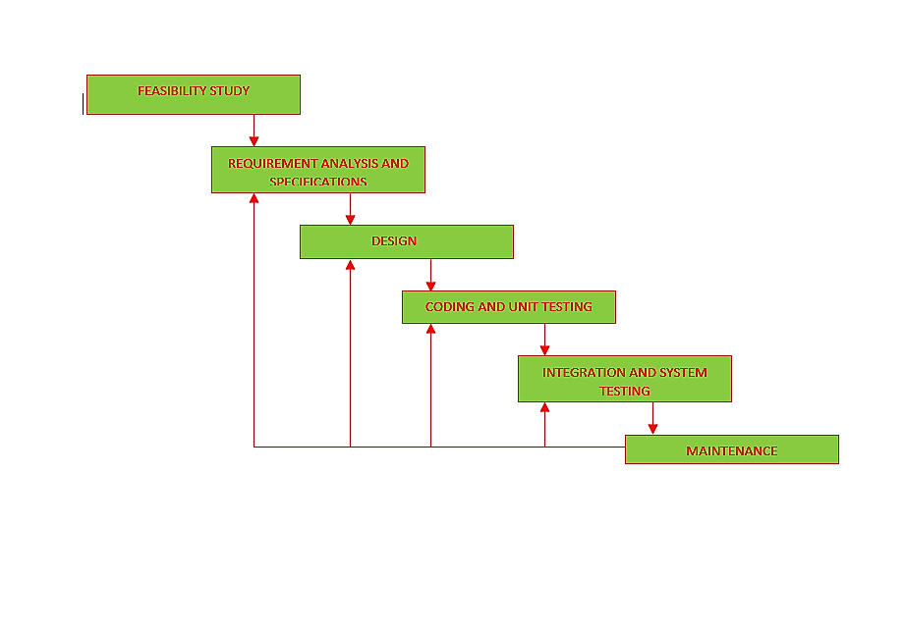

This project follows the iterative waterfall model

The iterative waterfall model provides feedback path before it’s preceding phase

***DONATE TO EDUCATE***

Pert chart:

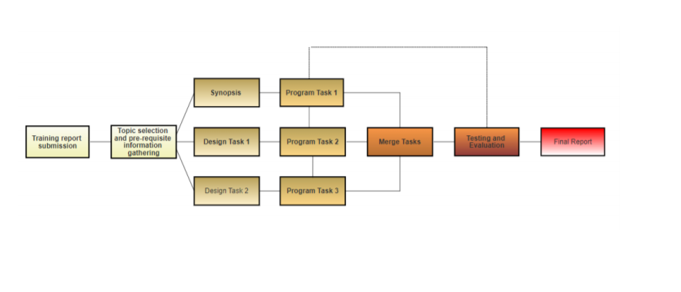

* Starting from information gathering about various donation website
* Designing the workflow of the game
* Developing it using Html CSS Javascript
* Testing it and making modifications to website
* Finally build the website

***DONATE TO EDUCATE***

***IMAGES OF THE WORKING SITE***



***DONATE TO EDUCATE***

***HOME PAGE***

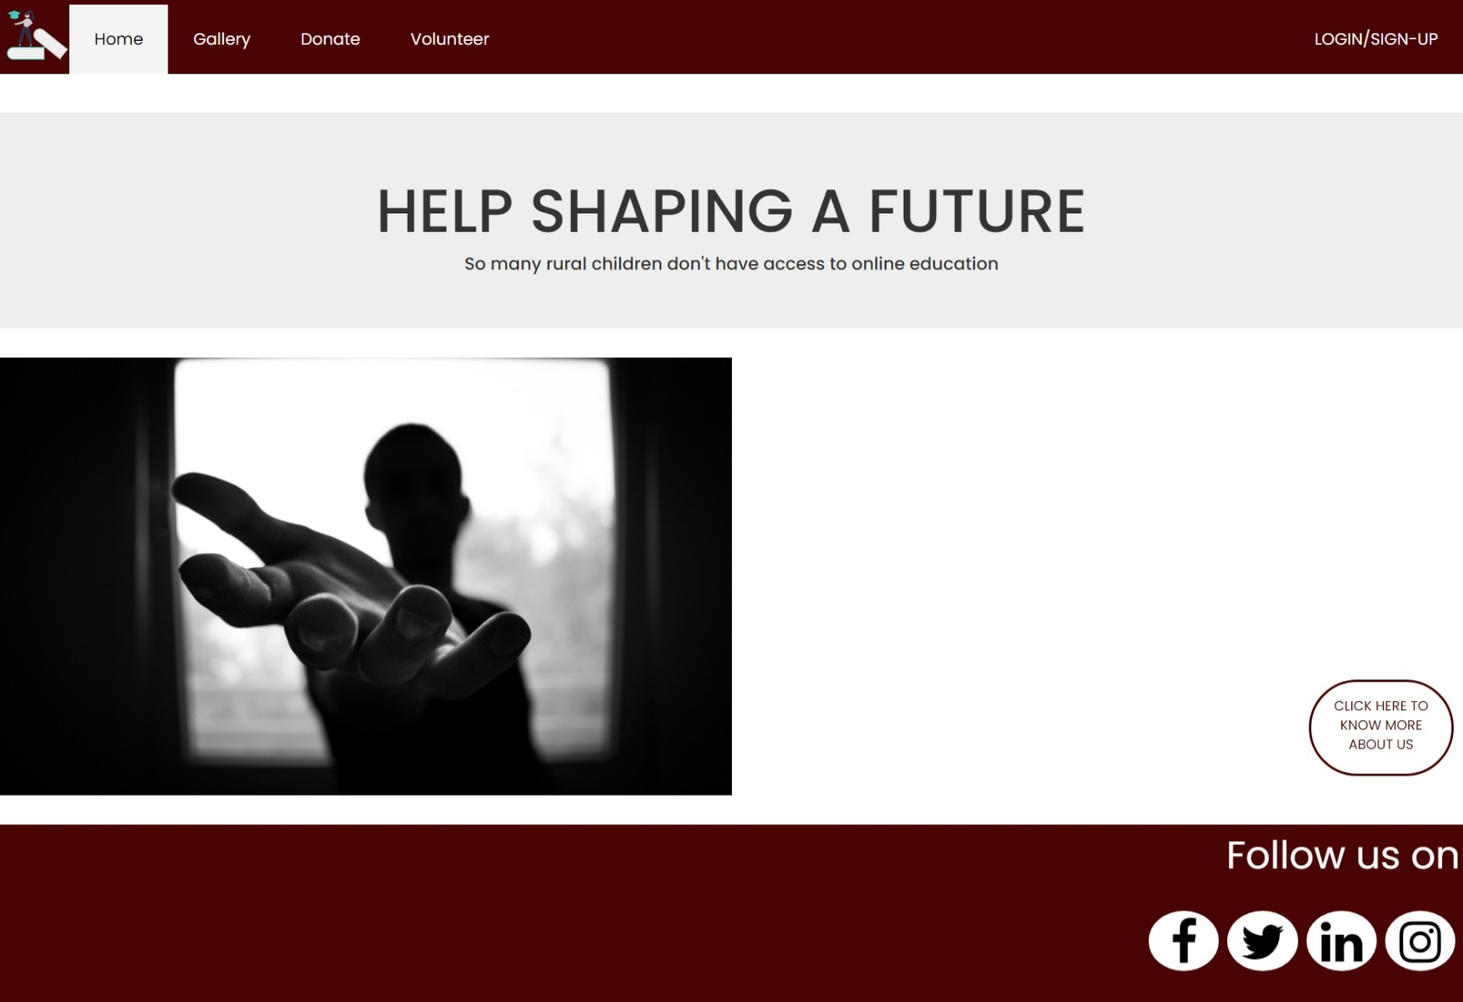

***DONATE TO EDUCATE***

***ABOUT-US PAGE***

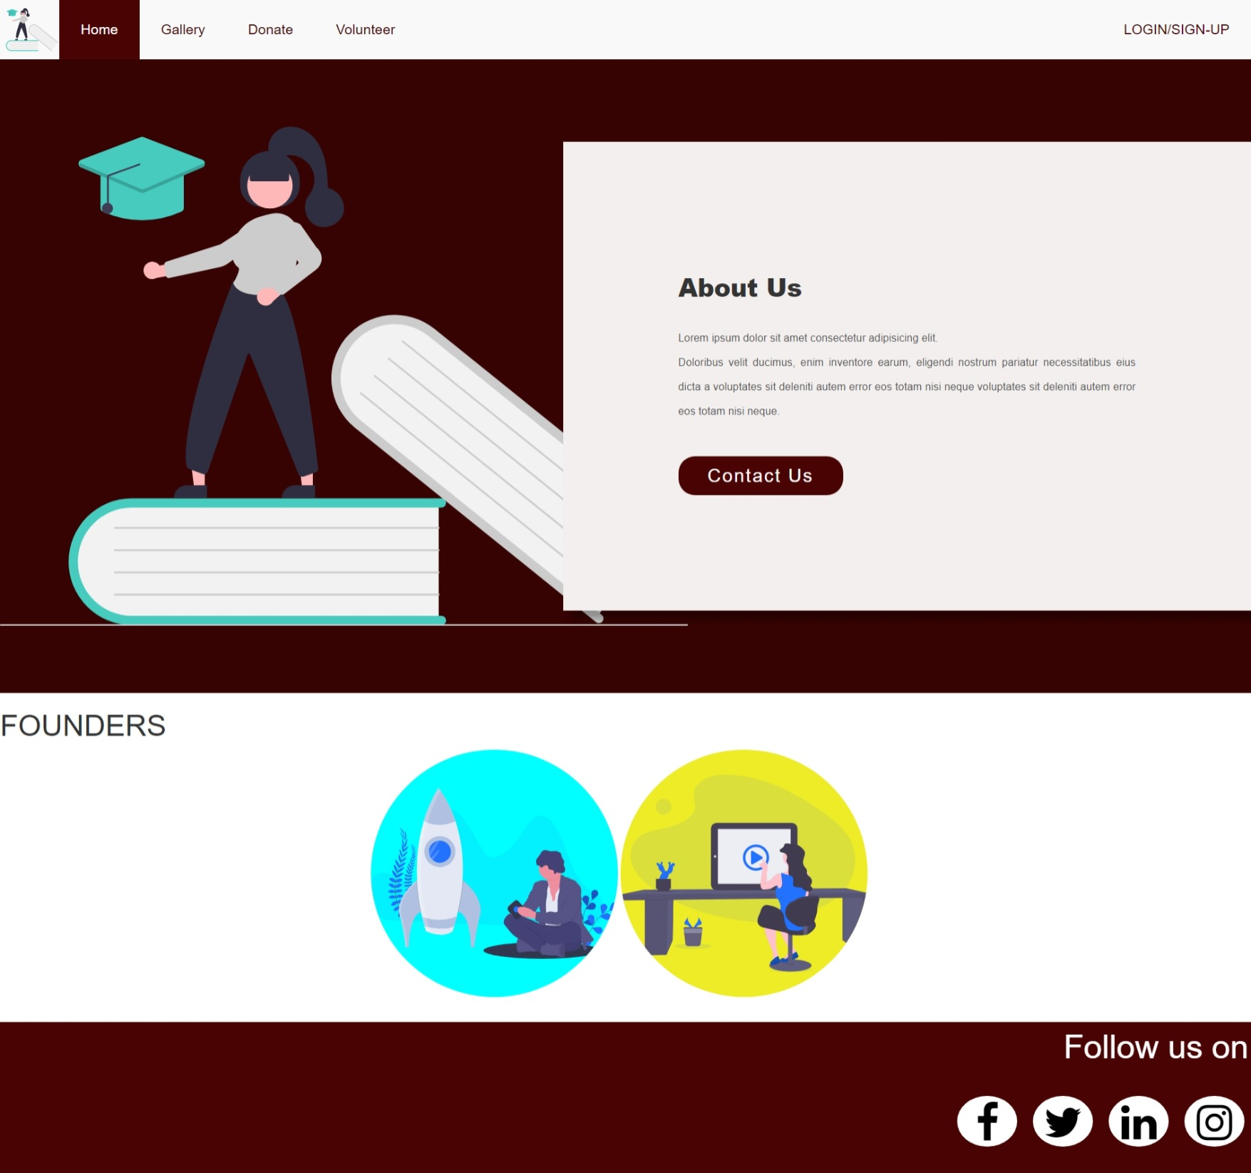

***DONATE TO EDUCATE***

***SIGN-IN/SIGN-UP PAGE***

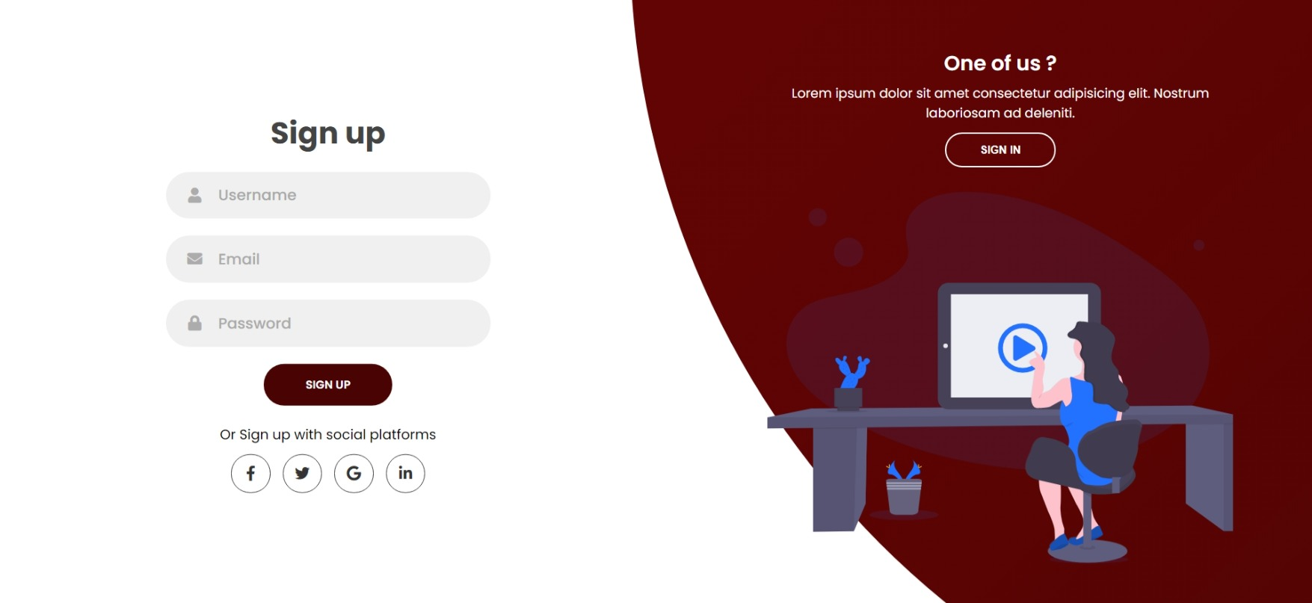

***DONATE TO EDUCATE***

***DONATION PAGE***

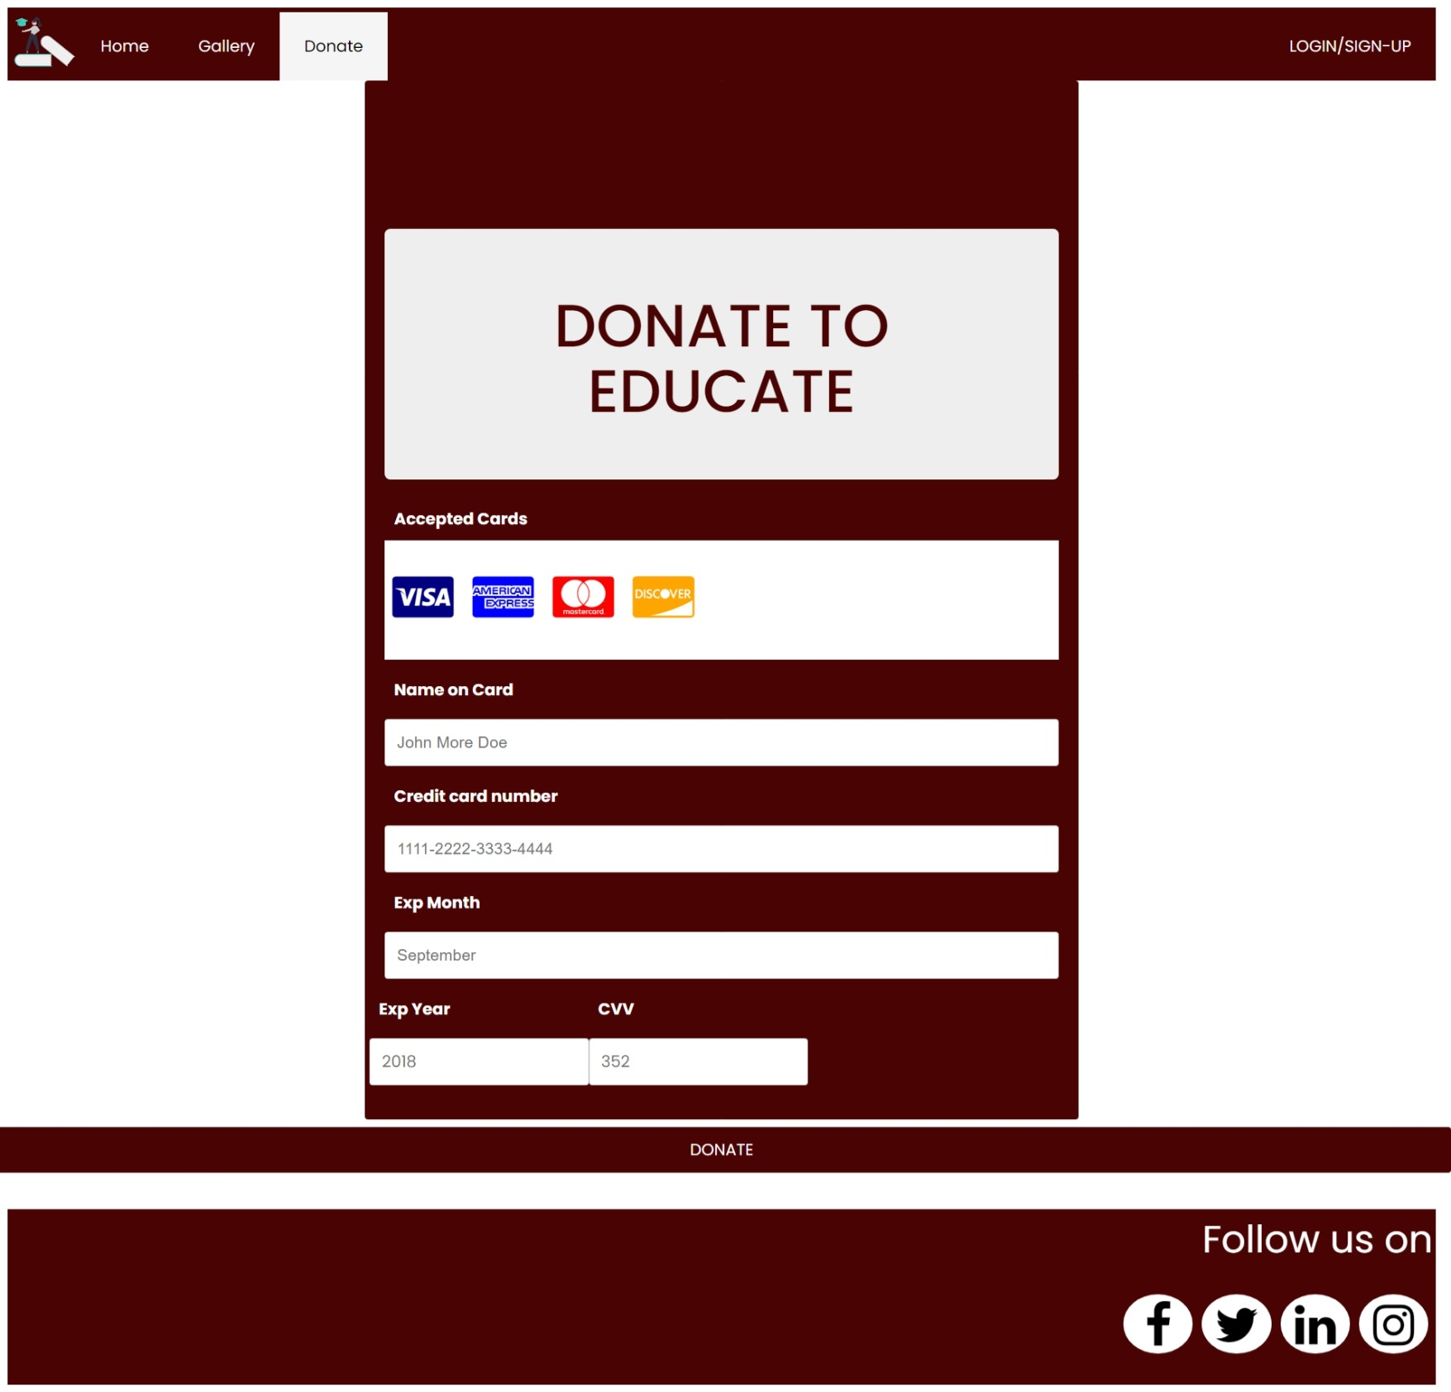

***DONATE TO EDUCATE***

Future scope:

There is no limits to what one can add on the website.

The website can be made more interactive by creating an online chatting forum.

Donation methodologies can be improved by providing different gateways.

The website can be made more interactive and Userfriendly.

***DONATE TO EDUCATE***

References:

[www.w3schools.com](http://www.w3schools.com)

YouTube

[www.giveindia.org](http://www.giveindia.org)